〓〓〓〓〓〓〓〓〓〓〓〓〓〓〓〓〓〓〓〓〓〓〓〓〓〓〓〓〓〓〓〓〓〓〓〓〓〓〓〓〓〓〓〓〓

Company Name | Korea Display Industry Association | Company Logo
Address | 211, Jungdae-ro, Songpa-gu, Seoul | 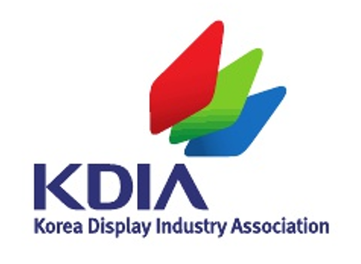
President | Yi Chung
Website | https://www.kdia.org/index.jsp?lng=en
E-mail | jyr@kdia.org
Telephone | 02-3014-5709
Fax
Exhibitor Introduction | “Building the Next Generation of Display Professionals”  The Korea Display Industry Association (KDIA) operates step-by-step talent development programs to systematically foster key professionals for the display industry
Exhibit Description | “Display Bootcamp” targets undergraduate students by supporting display-specialized curricula at participating universities. It offers hands-on project-based training and internships at related companies. KDIA supports the universities running the programs and facilitates partnerships with companies, enabling students to gain real-world industry experience.  “Display Academy” provides tailored training courses for both job seekers and current employees. Through a curriculum focused on practical skills, participants gain competencies that help them successfully advance into careers at top display companies.  “Program for Developing R&D Specialists (Master’s & Ph.D.)”  In partnership with top graduate schools in Korea, this program cultivates advanced R&D professionals who will lead the future of display technology. It focuses on building expertise in cutting-edge research to drive innovation across the industry.  Through these three step-by-step talent development programs, From undergraduate students to seasoned professionals, KDIA offers structured pathways for talent to grow within the display industry.  Be a part of the future of the display industry.
Exhibit Product | Brochure introducing KDIA’s talent development programs,  Best Practices Report

