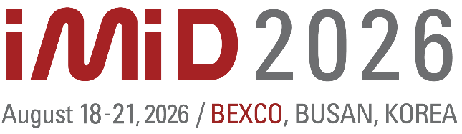


Sponsorship Application Form

Please fill out the below application form, and send it back to the secretariat.
IMID 2026 Secretariat
[Tel: 042-472-7460 / Fax: 042-472-7459 / E-mail (Sponsorship & Exhibition): imidex@k-ids.or.kr]

1. Company Information
■ Company Name
■ President |  | ■ Person in charge
■ Department
■ Address
■ Zip Code |  | ■ Country
■ Tel |  | ■ Fax
■ E-mail

2. Sponsorship (*VAT excluded)
Category | KRW | Apply | Category | KRW | Apply
01. Lounge | 40,000,000 | Sold Out | 14. Photo Booth | 3,000,000 | Sold Out
02. Banquet | 25,000,000 | Sold Out | 15. Vertical Banner  in Main Lobby (1 piece) | 3,000,000
03. Lanyard | 15,000,000 | Sold Out | 16. Fill out Desk | 3,000,000
04. Special Contributor Dinner | 10,000,000 | Sold Out | 17. Life-Size Standee | 3,000,000 | Sold Out
05. Poster Board | 10,000,000 |  | 18. Vertical Banner  in Exhibition Hall | 2,000,000
06. Registration Desk | 10,000,000 | Sold Out | 19. Message Board | 2,000,000
07. Large Vertical Banner  in Exhibition Hall | 10,000,000 |  | 20. Advertisement on [Program Book] | 1,000,000 | □ Inside Cover  □ Inner Page  □ Back Cover
08. Ceremony Wall | 10,000,000 |  | 21. Advertisement on [PPT Slide] | 1,000,000
09. Bridge Banner | 10,000,000
10. Photo Wall | 7,000,000 | Sold Out
11. Pen | 5,000,000 | Sold Out
12. Bottled Water | 5,000,000 | Sold Out
13. Preview / Cloak Booth | 5,000,000
※ All sponsorship categories are filled on a first-come, first-served basis.
3. Account Information
Account Holder: Korea Information Display Society (KIDS)
Account Number: 1010-1197-8797
Bank Name: SUHYUP BANK
Swift Code: NFFCKRSE
Bank Address: 11-6 Sincheon-dong, Songpa-gu, Seoul, Korea
Branch: Managing the Science & Technology Center Branch

Name of Applicant: Date:

Signature:

