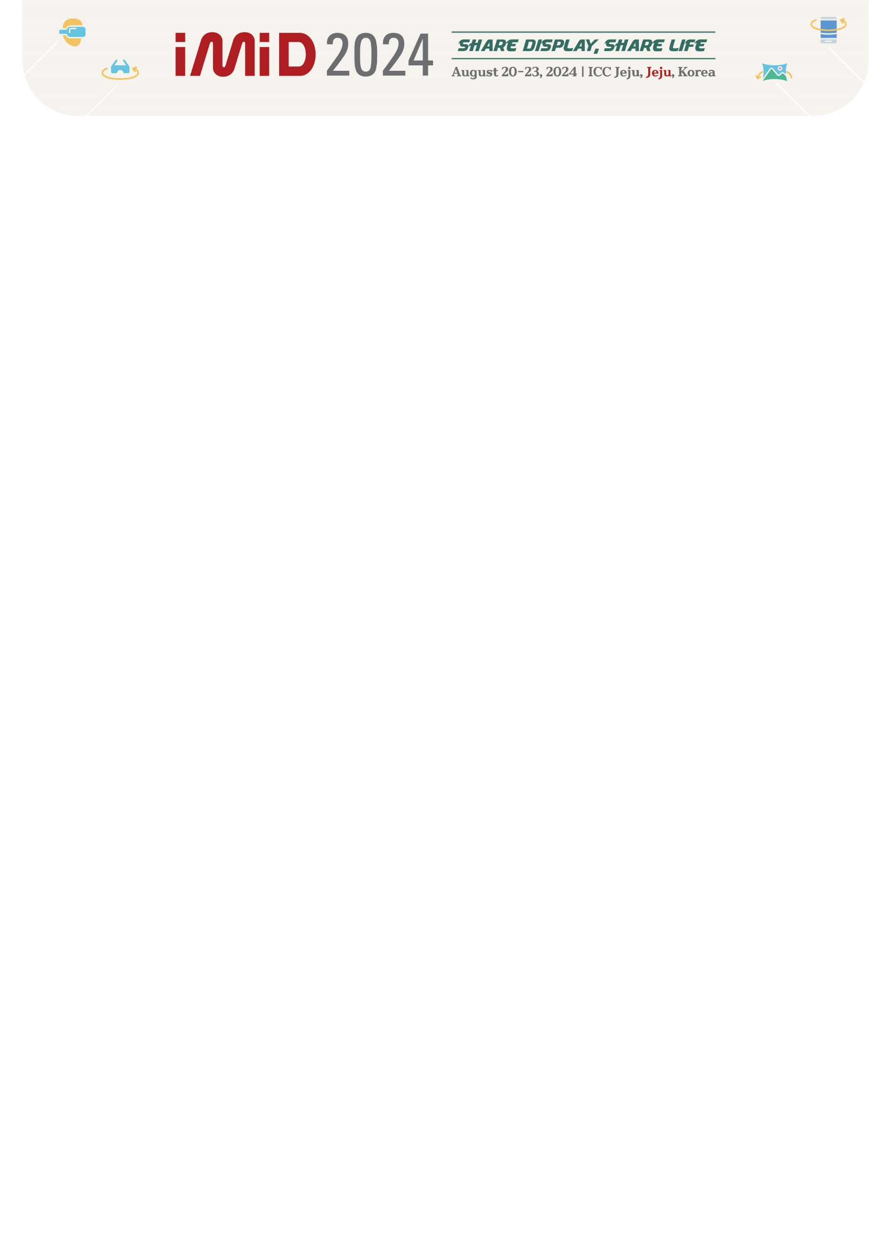

Exhibition Application Form
Please fill out the below application form, and send it back to the secretariat (imidex@k-ids.or.kr).
1. Information of the Company
■ Company Name
■ Company Title for Booth & Directory Book
(English Name, upper-lower case specified)
■ President |  | ■ Person in charge
■ Department
■ Address
■ Zip Code |  | ■ Country
■ Tel |  | ■ Fax
■ E-mail

2. Exhibition Application (No VAT)

Application  Deadline | KIDS / KDIA Membership |  | KIDS / KDIA Non-Membership
Application  Deadline | Independent Booth  (Space Only / 6M*6M) | Prefabricated Booth  (Standard / 3M*3M) | Independent Booth  (Space Only / 6M*6M) | Prefabricated Booth  (Standard / 3M*3M)
Early-Bird  (By April 30, 2024)  CLOSE | □ KRW 3,500,000  CLOSE | □ KRW 1,500,000 X ( ) | □ KRW 5,500,000 | □ KRW 2,000,000 X ( )
Advance  (By June 30, 2024) | □ KRW 4,500,000  CLOSE | □ KRW 1,700,000 X ( ) | □ KRW 6,700,000 | □ KRW 2,300,000 X ( )
Regular  (From July 1, 2024) | □ KRW 5,100,000 | □ KRW 1,900,000 X ( ) | □ KRW 7,500,000 | □ KRW 2,500,000 X ( )

3. Recruiting Booth
Application
- Attend | - Not Attend

Account Information
Account Holder: Korea Information Display Society (KIDS)
Account Number: 1010-1197-8797
Bank Name: SUHYUP BANK
Swift Code: NFFCKRSE
Bank Address: 22, Teheran-ro 7Gil, Gangnam-gu, Seoul, Korea, 06130
Branch: Managing the Science & Technology Center Branch

※ I, as a representative of this formally registered company, agree to and respect all the rules and guidelines as an exhibitor of IMID 2024.
.

Name of Applicant: Date:
Signature:

