IMID 2022 (Aug. 23-26, 2022)
Deadline for Reservation: 31, July, 2022
Reservation Form

*Check In Date: 2022.8. |  |  | *Check Out Date: 2022.8. |  | 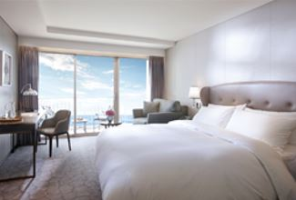  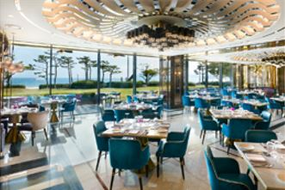  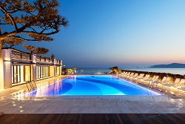
*No. of Persons:
*Name (Family/Given):
*Telephone: |  |  | *E-mail:
CREDIT CARD INFORMATION (For Guarantee Purpose)
*Credit Card: ☐Other ☐Visa ☐Masters ☐Amex(4digit-number: )
*Credit Card Number:
*Expiry Date: |  |  | *Card Holder’s Name:
SPECIAL ROOM RATE (Roon only Rate) (Unit: Korean Won)
Room Type |  |  | Monday ~ Thursday | *Friday | *Saturday | *Sunday
Main Bldg.(본관) | Deluxe City View |  | ☐ \326,700 (Double)  ☐ \326,700 (Twin) | Surcharge  +\96,800 | Surcharge  +\145,200 | Surcharge  +\36,300
Annex Bldg.(신관) | Deluxe Ocean View |  | ☐ \399,300 (Double)
Main Bldg.(본관) | Deluxe Ocean Terrace View |  | ☐ \435,600 (Double)  ☐ \435,600 (Twin)
☐ Allocation to Annex Building(신관배정요청): Surcharge \36,300/Night, ☐ Extra Bed(침대/침구 추가): \72,600/Night
☐ Buffet Breakfast (Adult \42,000, Children\29,000): Number of Adult: , Children: (children: 49months~elementary school)
*Breakfast may have limited availability if no reservation was made in advance. (조식은 사전 예약제로 현장에서 예약이 불가할 수 있습니다)
Remarks:
* The above mentioned room reservations may be closed in advance. (상기 예약은 호텔 사정에 의해 사전에 마감 될 수 있음)
* The rates above are non-commissionable, and they are Inclusive of 10% Service Charge and 11% Government Tax.
* The rates above are not inclusive of breakfast. (Breakfast reservations must be made, and may be closed in advance)
* Number of guests: 2 Adults (All rooms of the Building are non-smoking areas)
* Check-in time is 3p.m.(15h00) Check-out time is 11:00 a.m.(11h00). Past the mentioned check-out time, the following rates will be applied
(Until 3p.m.(15h00): 50% of the room rate, After 3p.m.(15h00): 100% of the room rate)
* Benefits Included(For 2Adults): Outdoor Ocean pool(Swimming pool), Fitness Club, Business Center, Paradise Kids Villages, Wi-Fi
* The leisure facilities(Ocean Pool, Fitness Club, Sauna, Spa ‘Cimer’) will be closed for maintenance every fourth Wednesday each month.
CANCELLATION POLICY
* Amendaments, Cancellations are availble upon following regulations: Hotel has the right to claim all room charge, which would be deducted from your guaranteed credit card. Cancellation or No-Show after the room reservation is being charged as below:
- From 7days to 5days prior to Arrival date(~18:00): 30% of the Room charge
- From 4days to 3days prior to Arrival date(~18:00): 50% of the Room charge
- From 2days or less prior to Arrival date(Includling No-Show): 100% of the Room chrarge
Please send your reservation form to: res@paradisehotel.co.kr (Tel no. +82.51.749.2111-3)

